Experiment no 5
Chaudhary Tuba Sharif
231410

Aim: To deploy web application on tomcat server

Step 1 : login to your GitHub and create a new repository take a sample maven project anf puch it in your directory
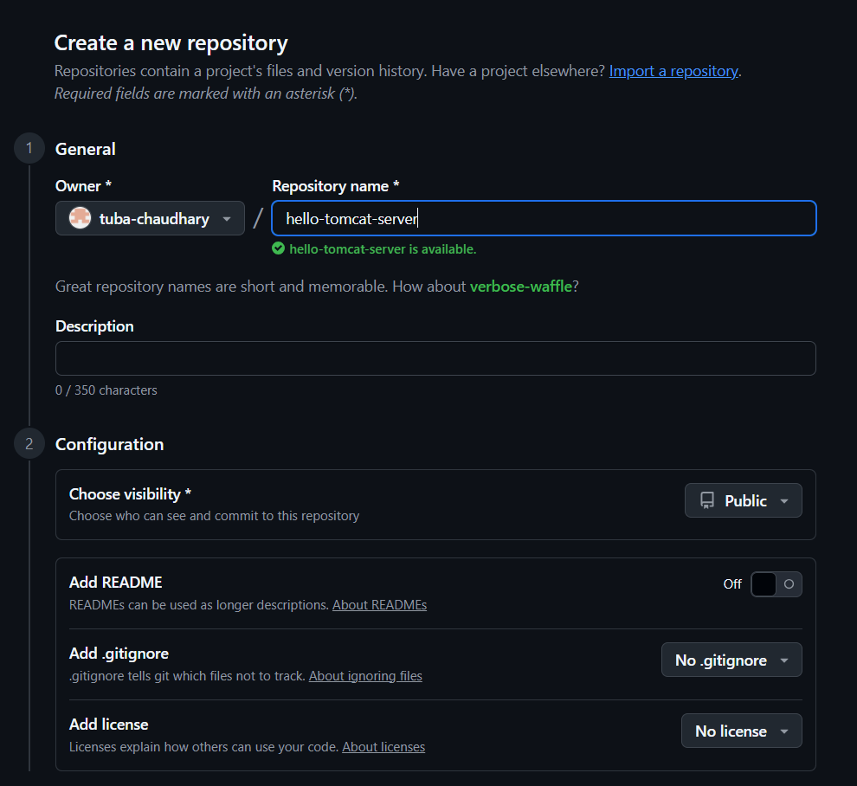
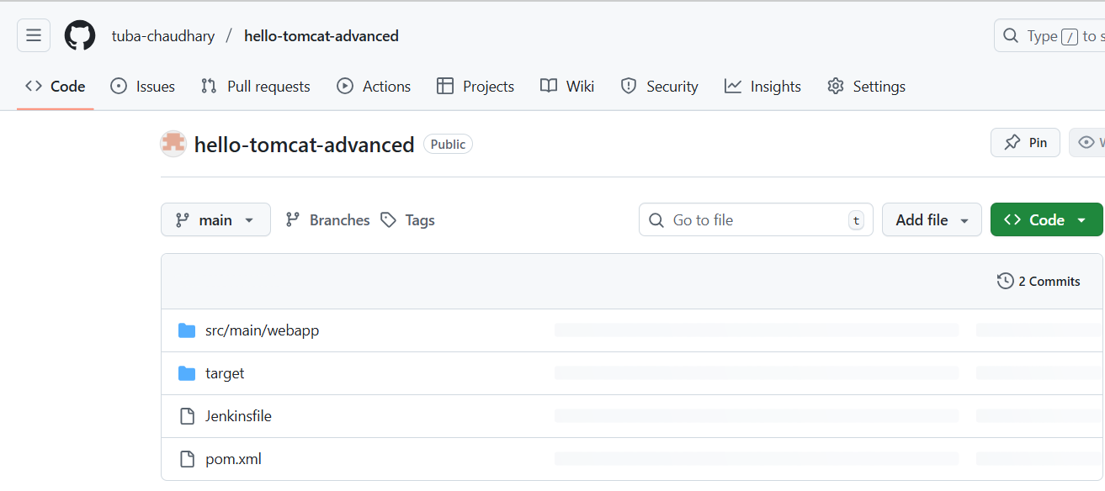

I have taken a simple project which includes .xml file now add a Jenkins file to it containing username and password of tomcat.
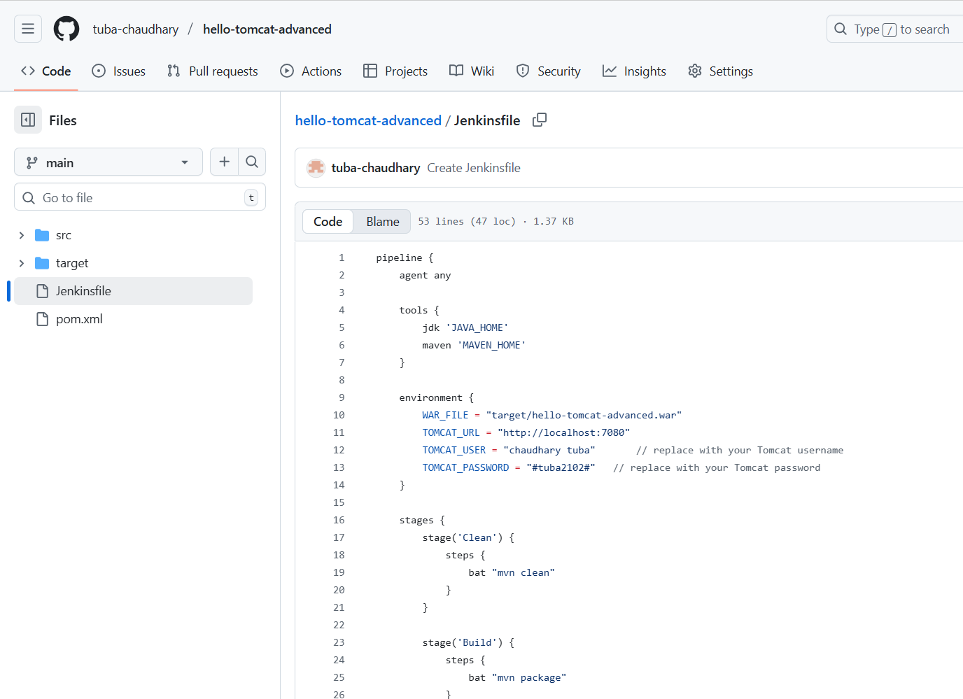

Step 2:
Download ZIP from Tomcat 9 Downloads → Core ZIP.
-Extract to c:/
-Open the C:\apache-tomcat-9.0.108\conf\server.xml file and edit port="7080"
Make sure that Jenkins and tomcat are running on different port no.
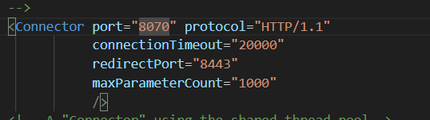
go to C:\apache-tomcat-9.0.108\conf\tomcat-users.xml file and add <role rolename="manager-gui"/>
<role rolename="manager-script"/>
<user username="tomcatuser" password="yourpassword" roles="manager-gui,manager-script"/> Inside the users tag;
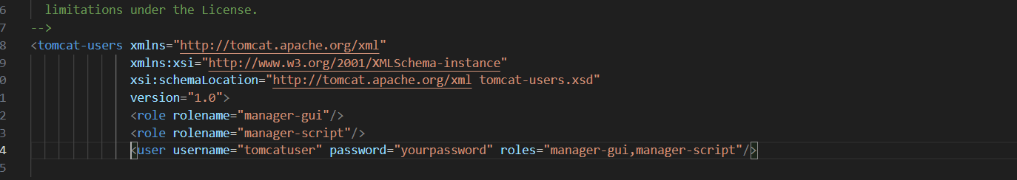
go to C:\apache-tomcat-9.0.108\webapps\manager\META-INF\context.xml and comment out <valve> code

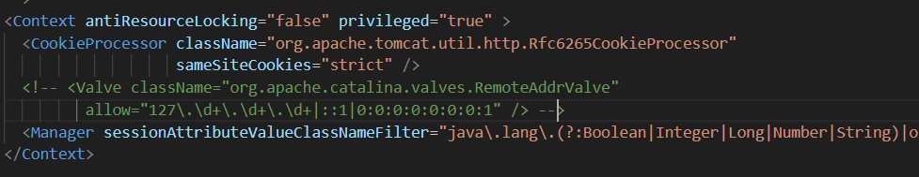

Go to C:\Users\LENOVO\Downloads \apache-tomcat-9.0.109\bin and open cmd
Type command startup.bat
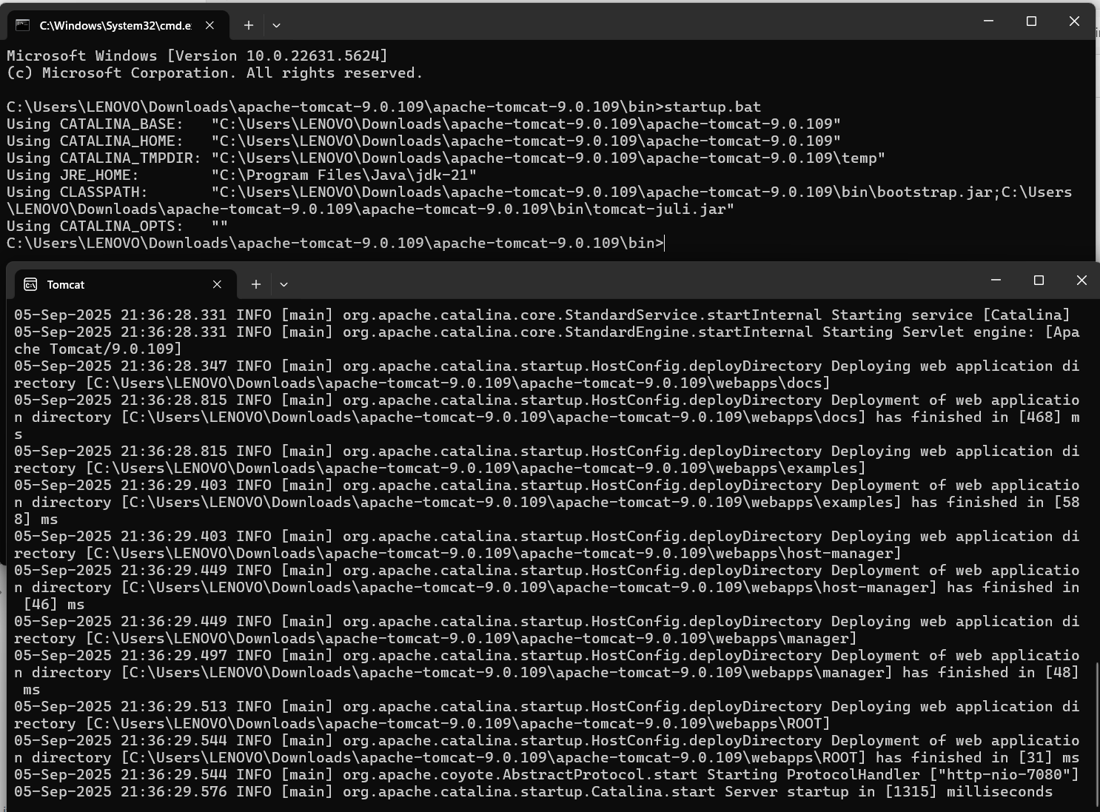

go to http://localhost:7080/ and open tomcat

v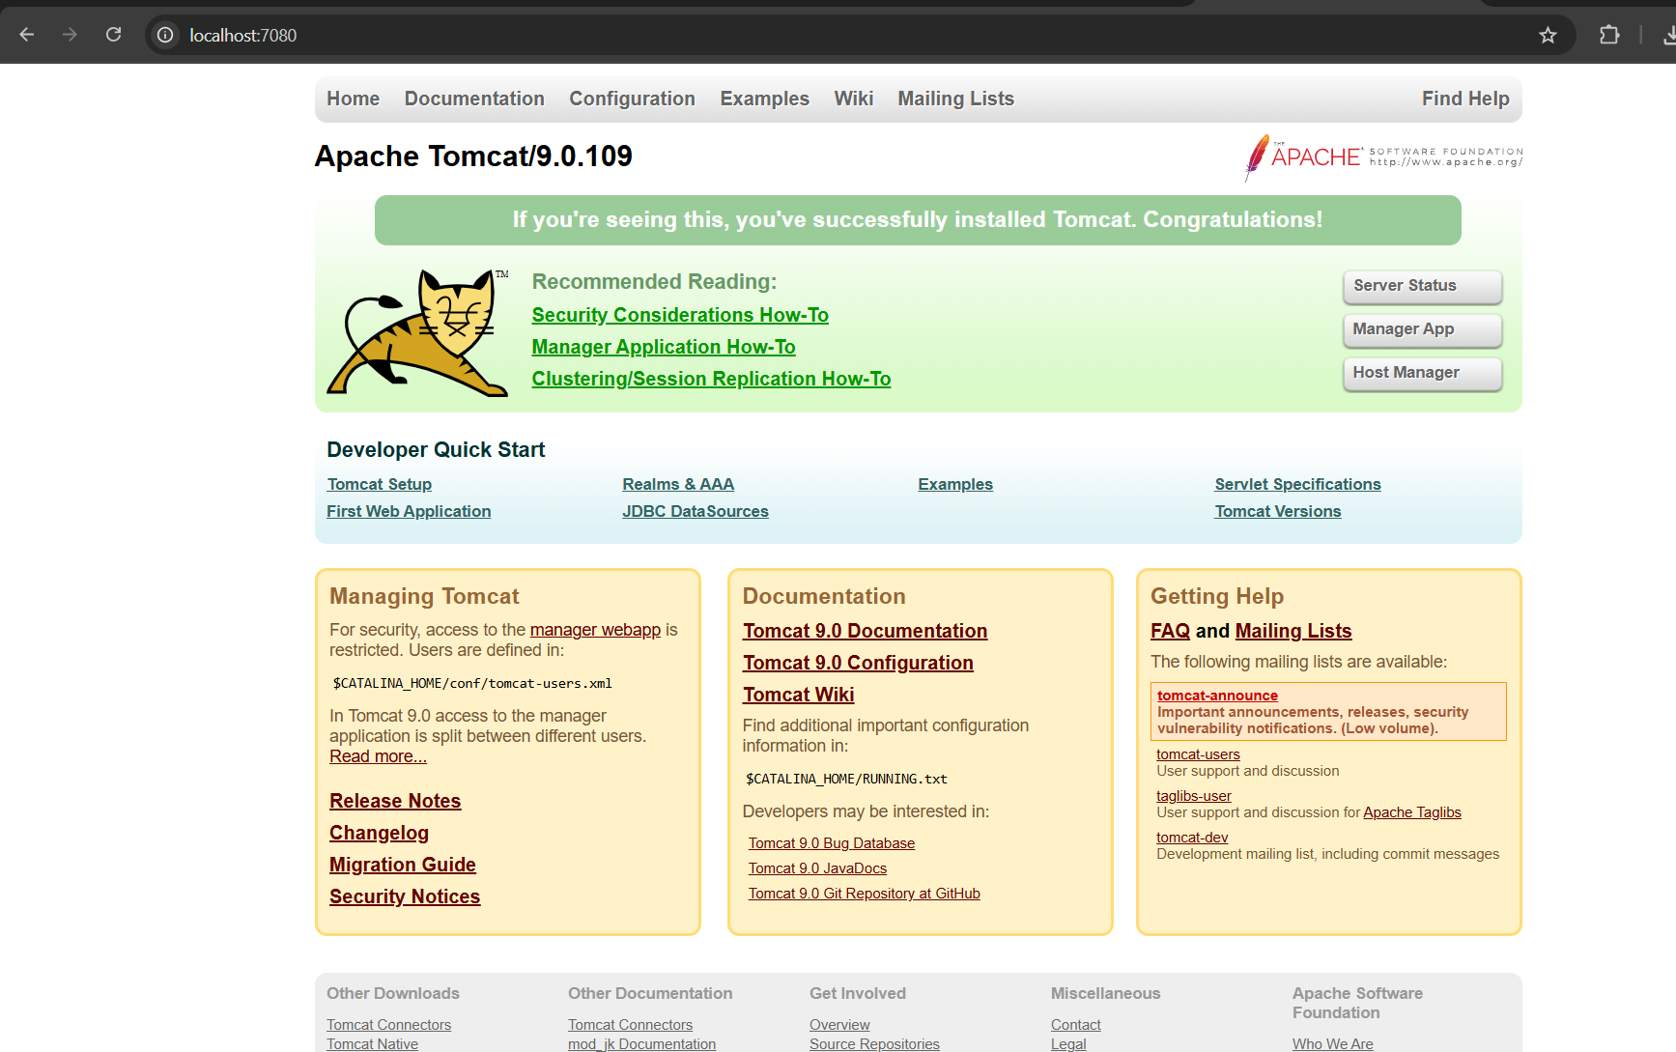

step 3: go to Jenkins and manage Jenkins --plugins
Install a Pulgin DEPLOY TO CONTAINER.

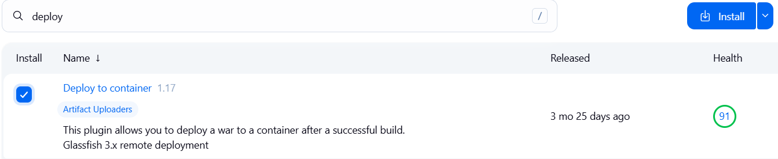

Step 4: now go to new item give it a name and select pipeline option
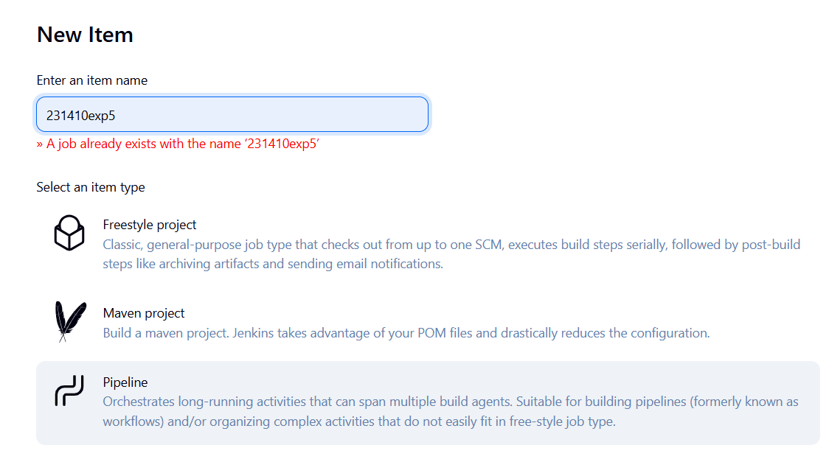
Give a description fill the required fields and give URL of the repository created earlier

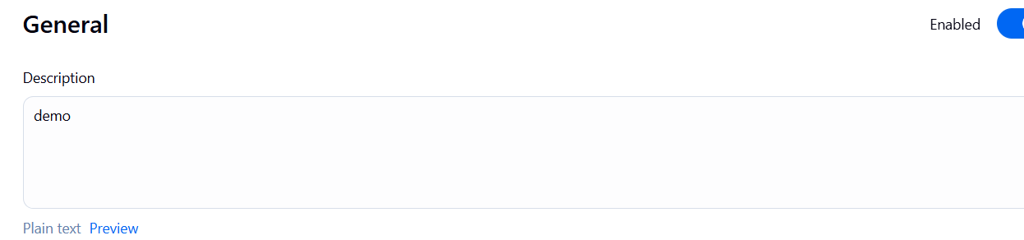
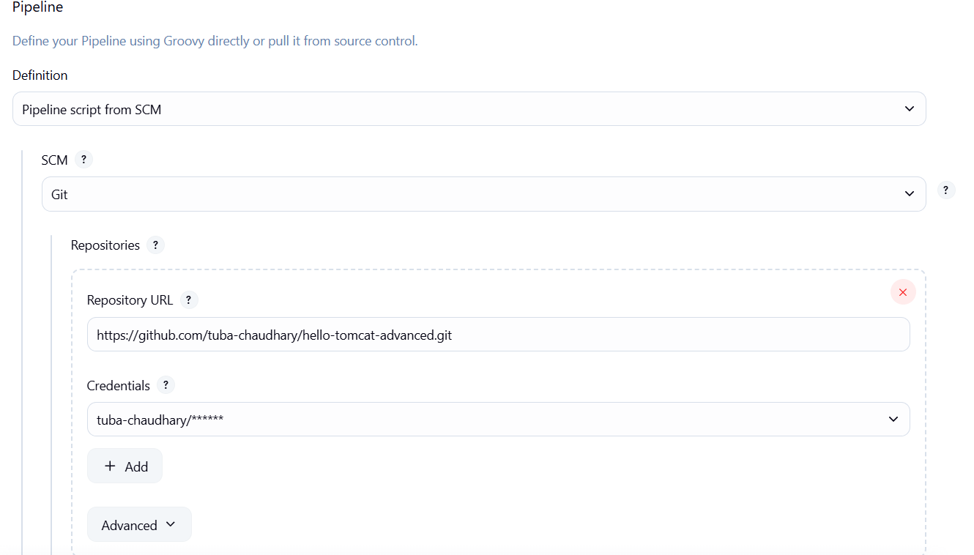

Click on build now and wait till the build is sucessfull
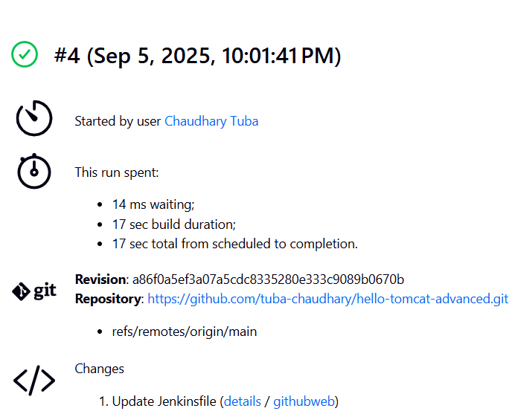

Step 5: go to C:\Users\LENOVO\Downloads \apache-tomcat-9.0.109\webapps you will see that a .war file is generated.

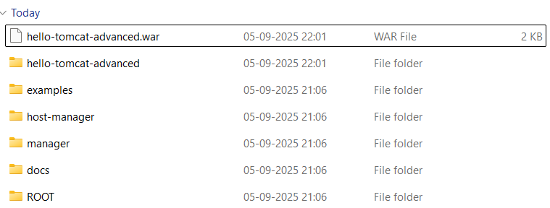

Step 6: go to tomcat manager app you will see the name of your project click on it.

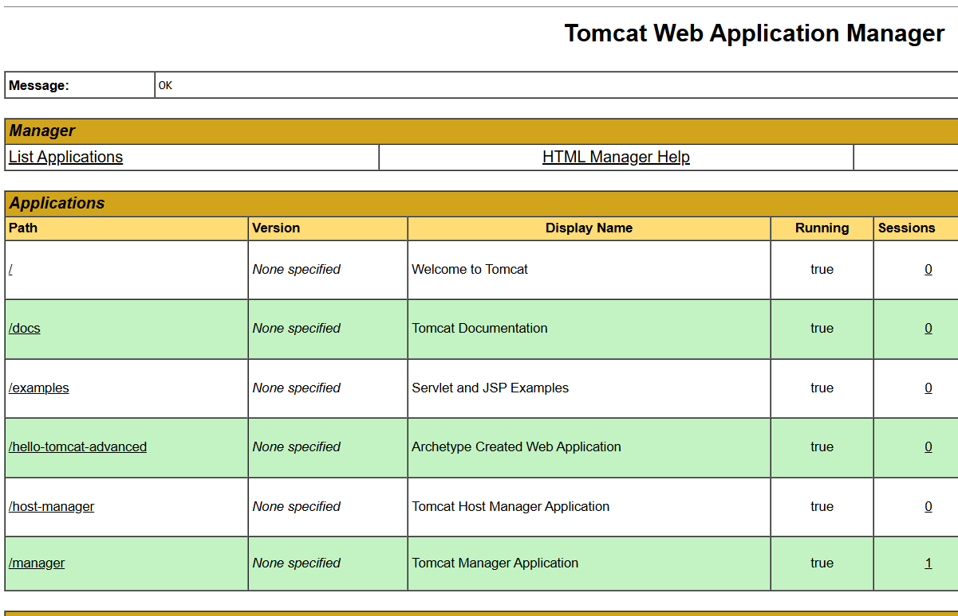

This shows that the project is successfully deployed.
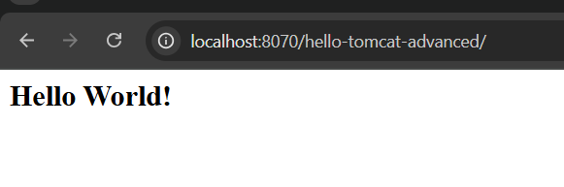

Conclusion: In this experiment, we integrated Apache Tomcat with Jenkins to automate deployment from a provided Git repository, ensuring smooth code fetch, build, and deployment to the server.
This setup demonstrates a practical CI/CD pipeline for real-world web application deployment.

